Task-1
Draw a diagram of the OSI 7-layer model and label each layer with its correct name and a real-world example of a device or protocol that operates at that layer (e.g., Switch at Data Link, HTTP at Application).
Ans:
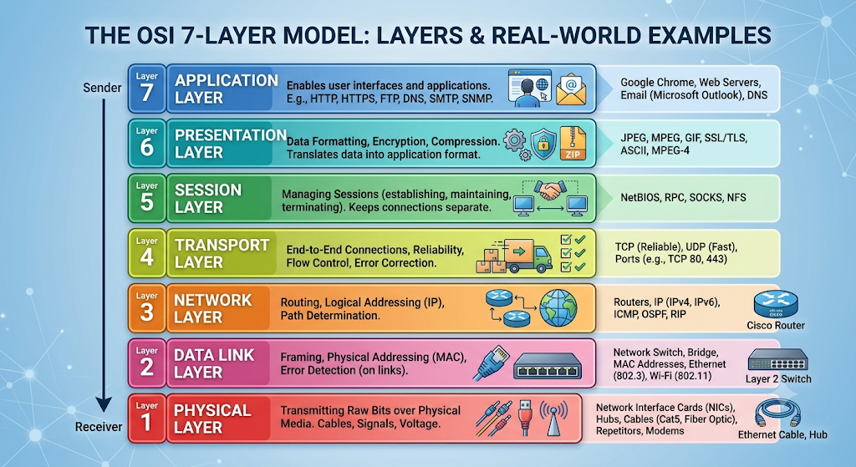

Task-2
Match the following networking scenarios to the correct OSI layer: a) Encrypting data before sending, b) Routing packets across networks, c) Converting data to electrical signals, d) Opening a web page in your browser, e) Detecting and correcting errors in frames.<br><br><em><strong>Hint:</strong> Write your answers as 'Scenario: Layer Name (Layer Number)'.</em>
Ans:
- a) Encrypting data before sending: Presentation Layer (Layer 6)
- b) Routing packets across networks: Network Layer (Layer 3)
- c) Converting data to electrical signals: Physical Layer (Layer 1)
- d) Opening a web page in your browser: Application Layer (Layer 7)

- e) Detecting and correcting errors in frames: Data Link Layer (Layer 2)
Task-3
Pick any app you use daily (like WhatsApp, Instagram, or Zomato) and describe how at least three different OSI layers are involved when you send or receive data in that app.
Ans:
When you send a message on WhatsApp, it moves down the OSI stack on your phone before traveling across the internet. Here is how three key layers handle that message:
- Layer 7: Application Layer
This is the layer your phone's WhatsApp client interacts with directly. When you type "Hello" and tap Send, the app formats your input into chat protocol payloads (historically based on XMPP/Noise protocol variations). It translates your user action into raw application data ready for transmission.
- Layer 6: Presentation Layer
WhatsApp uses end-to-end encryption (the Signal Protocol). At this layer, your plaintext message is transformed into unreadable ciphertext using cryptographic keys stored on your device. It also handles data formatting and compression (such as optimizing an image or voice note before transport) so the receiving device can interpret it properly after decryption.
- Layer 4: Transport Layer
Once encrypted, the message is passed to the transport layer, which relies primarily on TCP (Transmission Control Protocol) for chat delivery. TCP breaks the data into segments, assigns sequence numbers to guarantee they arrive in the correct order, and manages acknowledgments (ACKs) and retransmissions so your text doesn't vanish if packets drop.

Task: 4
Given this scenario: You are unable to access a website, but you can successfully ping its IP address. Identify which OSI layer(s) might be causing the problem and explain your reasoning.
Ans:
A successful ping confirms that Layers 1, 2, and 3 (Physical, Data Link, and Network) are working properly.
The issue lies in the higher layers:
- Layer 4 (Transport Layer): A firewall is blocking TCP port 80 (HTTP) or 443 (HTTPS), even though it allows ICMP ping packets.
- Layer 6 (Presentation Layer): An SSL/TLS handshake failure (e.g., expired or invalid security certificate) is preventing a secure connection.
- Layer 7 (Application Layer): The web server service (Apache/Nginx) is down, the site has an HTTP server error (e.g., 500/503), or there is a DNS failure resolving the website name.

